INTRODUCTION TO TWO-HINGED ARCHES

1.0. TWO-HINGED ARCHES:-

The following issues should be settled first.
− Definition.
− Types.
− Basic Principle and B.M.
− Linear Arch.
− Mathematical Generalized Expressions.
− Segmental Arches.

1.1. DEFINITION OF AN ARCH.

“An arch can be defined as a humped or curved beam subjected to transverse and other loads as well as the horizontal thrust at the supports.” An efficient use of an arch can be made only if full horizontal restraint is developed at the supports. If either of the support allows some movement in the horizontal direction, it will tend to increase the B.M. to which an arch is subjected and arch would become simply a
curved beam.

The B.M., in arches due to the applied loads is reduced due to the inward thrust. Analysis is carried out to find the horizontal thrust and also to find the B.M., to which an arch is subjected.
Beam action Vs arch action :
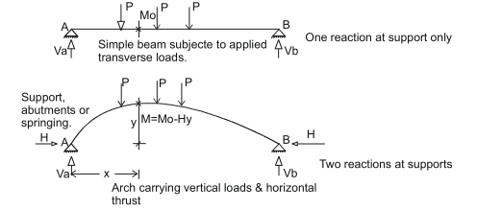
The above beam and arch carry similar loadings.
If Mo = B.M. due to applied loads at a distance X on the simple span of a simple beam where rise is y.
then bending moment in the arch is, M X = Mo ± Hy

where M X is the B.M., in the arch at a distance x . H is the horizontal thrust at the springings & y is the rize of the arch at a distance. ‘x’ as shown in the diagram. The ( ± ) sign is to be used with care and a (−) sign will be used if the horizontal thrust is inwards or vice versa . In later case it will behave as a beam.
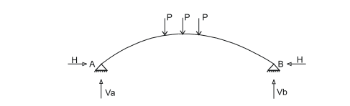
Under transverse loads, the horizontal thrust at either of the springings abutments is equal. In the arch shown above, the degree of indeterminacy is one and let us consider the horizontal thrust at support B as the redundant. The above loaded arch can be considered equal to the following two diagrams wherein a BDS arch is under the action of loads plus the same BDS arch under the action of inward unit horizontal load at the springings.
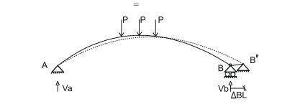
B.D.S. under applied loads (loads try to flatten the arch)
∆BL stands for displacement of point B due to applied loads in a BDS arch..
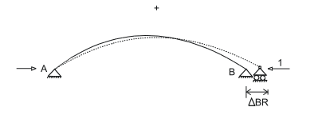
(Flattened arch recovers some of horizontal displacement at B due to unit horizontal loads and will recover fully if full horizontal thirst is applied at B.)
(Arch flattens out under the action of applied loads because freedom in the horizontal direction has been provided at point B.) and all due to full redundant value. This forces the basis of compatibility.
∆BR stands for displacement of point. B (in the direction of force) due to unit horizontal redundant force at B. Remember that a horizontal reactive component cannot be realized at the roller support. However, we can always apply a horizontal force at the roller.

1.2. COMPATIBILITY EQUATION .

∆BL − ( ∆BR ) H = 0 ( If unit load is applied in opposite sense so that it also produces flettening, +ve sign may be used in the equation and the final sign with H will be self adjusting.)

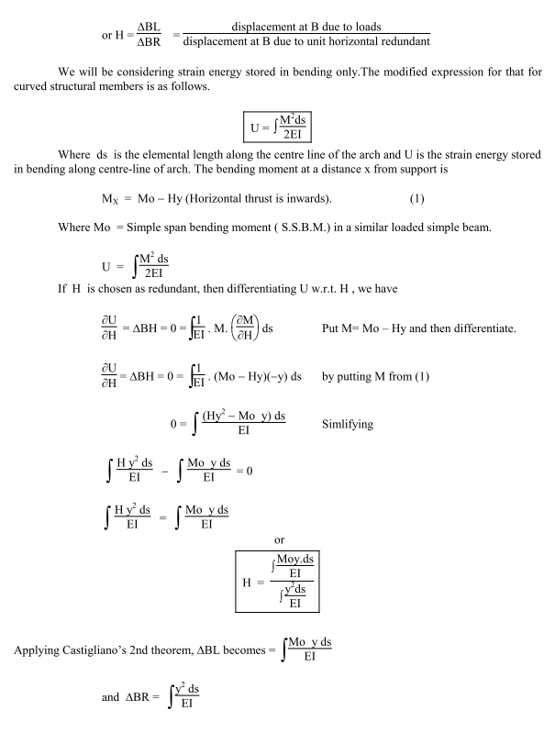

The algebraic integration of the above integrals can also be performed in limited number of cases when EI is a suitable function of S ( total curved arch length), otherwise, go for numerical integration.
For prismatic (same cross section) members which normally have EI constant, the above expression can be written as follows:
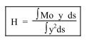
1.3. TYPES OF ARCHES :−

The arches can be classified into a variety of ways depending mainly upon the material of construction and the end conditions.

(1 ) Classification Of Arches Based On Material of Construction :−

The following arches fall in this particular category:
a) Brick masonary arches.
b) Reinforced concrete arches.
c) Steel arches.

The span of the arches which can be permitted increases as we approach steel arches from the brick masonary arches.

(2 ) Classification Of Arches Based On End Conditions :−

The following arches fall in this particular category:
a) Three hinged arches.
b) Two hinged arches.
c) Fixed arches.
In the ancient times, three hinged arches have been used to support wide spans roofs. However, their use is very rare in bridge construction since the discontinuity at the crown hinge is communicated to the main deck of the bridge. In three hinged arches, all reactive components are found by statical considerations without considering the deformations of the arch rib. Therefore, they are insensitive to foundation movements and temperature changes etc., and are statically determinate. These are covered as a separate chapter in this book.

The Romans exploited the potential of arches to a great extent. However, their emperical analysis approach became available in the early 18th century.

1.4. LINEAR ARCH :−

This is just a theoretical arch at every X−section of which the B.M. is zero.
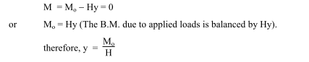

1.5. ANALYSIS OF TWO HINGED CIRCULAR ARCHES :−
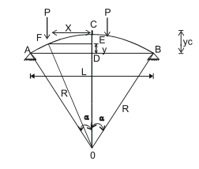
The circular arches are infact a portion of the circle and are commonly used in bridge construction. From the knowledge of determinate circular arches, it is known that the maximum thrust and the vertical reactions occur at the springings. Therefore, logically there should be a greater moment of inertia near the springings rather than that near the mid−span of the arch. The approach is called the secant variation of inertia and is most economical. However, to establish the basic principles, we will first of all consider arches with constant EI. The following points are normally required to be calculated in the analysis.
(1) Horizontal thrust at the springings.
(2) B.M. & the normal S.F. at any section of the arch.
Usually, the span and the central rise is given and we have to determine;
(i) the radius of the arch;
(ii) the equation of centre line of the circular arch.
Two possible analysis are performed.
(1) Algebraic integration.
(2) Numerical integration.

After solving some problems, it will be amply demonstrated that algebraic integration is very laborious and time consuming for most of the cases. Therefore, more emphasis will be placed on numerical integration which is not as exact but gives sufficiently reliable results. Some researches have shown that if arch is divided in sixteen portions, the results obtained are sufficiently accurate. In general, the accuracy
increases with the increase or more in number of sub−divisions of the arch.

We will be considering two triangles.
1 − ∆ ADO
2 − ∆EFO
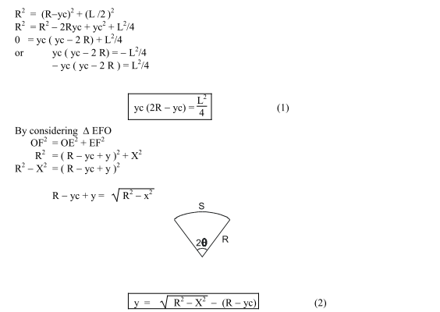
The detailed derivation of this equation can be found in some other Chapter of this book. In this case, S = R ( 2 θ ) where θ is in radiains. S is the total length along centre line of the arch.

PART – 2

ANIMATION STEPS

PART – 3
VIRTUAL LAB FRAME

